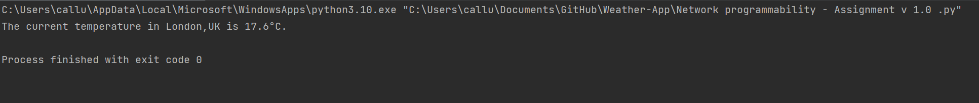

Code seems to be working correctly from my side. Returning the expected outcome for London City with exit code 0. I also tested this against the weather in London at the time on the Met Office as shown below:

A recommendation for troubleshooting would be to add these lines into a function as I can use the ‘Unitest’ package to properly test and debug the code. May also be worth looking into a User Interface for the app, or a method of letting the users input the required location into the python code.